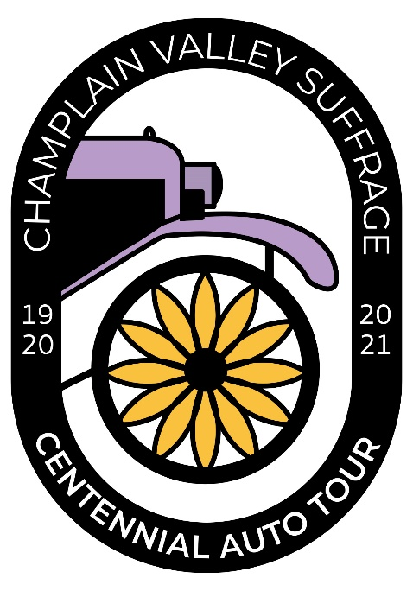
Press Release

Champlain Valley Suffrage Centennial
2021 Auto Tour Events Schedule
July 31, August 6-7, August 14, August 21
The Champlain Valley Suffrage Centennial Auto Tour was rescheduled from last year with the full commitment of our grantor the Champlain Valley National Heritage Partnership. The tour commemorates and celebrates the passing of the 19th Amendment in 1920 and recognizes and demonstrates the many ways women fought for the right to vote prior to 1920. Special attention is given to hometown and national heroes throughout the 4-weekend event. Event details are available on the website champlainvalleywomen.com and on the Facebook page Champlain Valley Suffrage Centennial Auto Tour. All events are free and open to the public. A summary of events follows.
July 31, 2021
Opening events of Auto Tour
10 am to 12 noon, CCHA 98 Ohio Avenue, Plattsburgh
Opening event of the Champlain Valley Suffrage Auto tour will include speeches by Susan B Anthony and three Clinton County suffragists, Marian Inman Parkhurst, Hannah Straight Lansing and Harriet Dudley Bell, who made their mark on their community and New York State with their commitment to woman suffrage. Displays will tell the local and state suffrage story with a special exhibit by Champlain Valley National Heritage Partnership. Suffragists will leave in vintage cars for the North Star Museum at noon.
Contact: Helen Nerska, 518-561-0340, director@clintoncountyhistorical.org

1 pm to 3 pm, North Star Underground Railroad Museum, Pavilion at Ausable Chasm.
The North Country Underground Railroad Historical Association Centennial Suffrage afternoon event will focus on three African American women who were strong leaders in their community, Ida Wells-Barnett, Portia S. Blackiston and Helen Appo Cook. There will be reenactments and speeches. Each of these women were educators and played major roles in their community. Portia spent time in the Westport area, Helen in North Elba and Ida was in New York City when her newspaper building was burned down.
Contact: Jacqueline Madison, 518-572-9552, ugr@frontier.com

August 6-7, 2021
The Lewis and Elizabethtown events focus on the life of suffragist hero Inez Milholland who gave her life for the movement and is remembered annually for her commitment and contributions to obtaining votes for women.
August 6

4:00 pm, Mount Inez, Lewis

A special pre-tour event, a hike up Mount Inez , hosted by CATS (Champlain Area Trails).

August 7

11:00 am to 2:00 pm, Lewis Congregational Church

The Auto Tour continues with Inez Milholland and antique automobiles leading a suffrage procession. There will be a celebration of Inez’s 135th birthday, the naming of Mount Inez, and the creation of an Inez Milholland Trail in Thrall Dam Park. Attendees can also listen to talks about the Milholland family, join a procession to Inez’s grave, participate in a broom brigade, and make suffrage crafts. There will be self-guided tours inside the Church, at Lewis Town Hall (Inez history exhibit), and at Veterans’ Memorial Park.

2:00 pm to 3:30 pm, Meadowmount School of Music

The tour will proceed to the Meadowmount School of Music, which was previously the Milholland estate. The Meadowmount grounds and the first floor of the main house will be open.

4:00 pm to 7:00 pm, Elizabethtown

The Auto Tour rolls into Elizabethtown, stopping at the Courtyard in front of the Essex County Courthouse. Welcoming speeches will be followed by addresses from Inez Milholland and anti-suffragist Dr. Charles Dana. Attendees can participate in a broom brigade and then catch a ride in a Model A to view suffrage-related exhibits at the Adirondack History Museum and the Hale Law Library. The celebration will end at the pavilion
behind the Museum with the spectacular Adirondack folk-duo Peggy Lynn and Dan Duggan
presenting their Songs of Suffrage concert, “Forward Into Light.”

Contact: Sandra Weber, 518-873-1137, weber@sandraweber.com

August 14, 2021

10:00 am to 12 noon, Lake Champlain Maritime Museum, Vergennes, VT

Visit the Suffrage displays at the Lake Champlain Maritime Museum. The museum is open and free for all to visit. Featured exhibits include: Women’s VOTE Centennial, an outside display celebrating the anniversary of the 19th Amendment and working toward a future of equity, respect and justice for all; Women at the Helm, a display featuring women leaders of the Champlain Valley from the 1700s to today; The Noble Failure: Prohibition in the Champlain Valley, a new outside exhibit exploring the complex relationship between government and individuals and changing attitudes about alcohol consumption over time. The replica canal schooner Lois McClure is dock in the Museum’s North Harbor and open, conditions permitting.

Contact: Meg Salocks, 802-475-2022 x116, meg@lcmm.org

12:30 pm to 3 pm Chimney Point Historic Site, VT

The Suffrage Auto Tour will travel from the Lake Champlain Maritime Museum to Chimney Point. Historic personages will be on hand to talk with people about the contributions and challenging lives of some of the early French and Vermont women here and provide some show and tell. Try your hand at turning the crank for home-made ice cream; enjoy a sample while it lasts.

Contact: Elsa Gilbertson, 802-759-2412, Elsa.Gilbertson@vermont.gov

3:00 pm Lake Champlain Bridge, Procession on Lake Champlain Bridge

Suffrage Procession across the Bridge

August 21
12 noon to 3 pm, City Park and Crandall Public Library, Glens Falls, NY
The final stop on the Champlain Valley Suffrage Centennial Auto Tour is beautiful City Park in downtown Glens Falls, NY. The Folklife Center at Crandall Public Library will host the Suffrage pageant Forward Into Light Reimagined. Actors in white will perform the history of women’s rights throughout the ages, along with songs and a chorus of "The March of the Women" by Dame Ethel Smyth. Before and after the pageant the audience is invited to participate in the Broom Brigade, Votes for Women! Story time, and children’s activities. Suffrage and local women’s history exhibits sponsored by Warren County Historical Society, the Chapman Museum, and Champlain Valley National Heritage Partnership will be on display outside. Inside the Library in the Folklife Galleries, visit Equali-tea: Suffragist in Redwork, an exhibit of 42 embroidered portraits on NY suffragists.
Contact: Tisha Dolton, 518-792-6508 x292, pdolton@sals.edu
For more information contact CVSCAT coordinator, Tisha Dolton (518-792-6508, ex292) and/or the coordinators for each weekend.

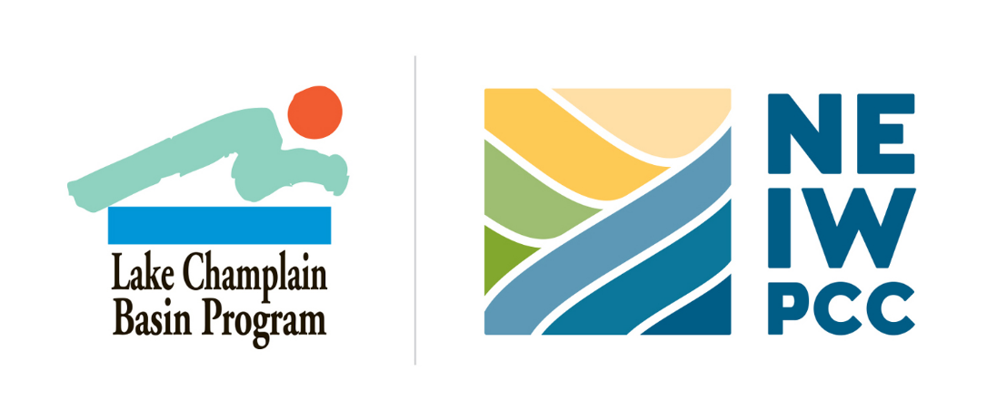
This project has been funded by an agreement awarded by the Great Lakes Fishery Commission (GLFC) to NEIWPCC in partnership with the Lake Champlain Basin Program (LCBP). The contents of this document do not necessarily reflect the views and policies of NEIWPCC, LCBP, or GLFC, nor does NEIWPCC, LCBP, or GLFC endorse trade names or recommend the use of commercial products mentioned in this document.

