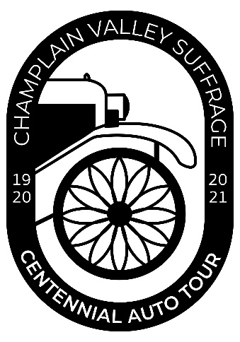
FOR IMMEDIATE RELEASE
June 25, 2021
Contact: Helen Nerska, Director
Clinton County Historical Association
518-561-0340
director@clintoncountyhistorical.org

CLINTON COUNTY HISTORICAL ASSOCIATION RECEIVES GRANT FROM
NEIWPCC AND THE LAKE CHAMPLAIN BASIN PROGRAM

PLATTSBURGH, NY— Clinton County Historical Association (CCHA) received a $15,000 Champlain Valley National Heritage Partnership (CVNHP) Special Program grant from the Lake Champlain Basin Program to support a series of regional events this summer called The Champlain Valley Suffrage Centennial Auto Tour.

The Champlain Valley Suffrage Centennial Auto Tour will take place on successive weekends from July 31 through August 21, 2021 to celebrate the 101st anniversary of the ratification of the 19th Amendment. The tour will pay homage to the effective strategies that suffragists employed locally as well as nationally — rallies, pageants, parades, speeches, and auto tours. Antique automobiles and costumed participants will create the atmosphere of the era of the suffrage movement. Planned events include, but are not limited to: (1) re-enactment of Susan B. Anthony’s speeches; (2) re-enactments of the military-style drills of “Broom Brigades”; (3) re-enactment of the 1924 “Forward into Light” pageant organized by National Woman’s Party leader Alice Paul to honor suffrage martyr Inez Milholland; (4) discussion of intersectionality and racism in the women’s suffrage movement and highlighting suffragists of color; (5) a cavalcade of cars and costumed re-enactors crossing the Champlain Bridge from Addison, VT to Crown Point, NY; (6) suffrage song concert by Peggy Lynn and Dan Duggan.

Various regional organizations will help with the presentation of history and the activities at each location. In addition to CCHA, the following sites and municipalities are hosting events of the auto tour: North Country Underground Railroad Historical Association in Ausable Chasm; the towns of Lewis and Elizabethtown; Meadowmount School of Music; Lake Champlain Maritime Museum in Vergennes, VT; Chimney Point State Historic Site in Addison, VT; and Crandall Public Library in Glens Falls. For more information on dates and times visit champlainvalleywomen.com.

“We are grateful to the Lake Champlain Basin Program for the CVNHP funds to assist in our ambitious multi-day, multi-event celebration covering two states, four counties, and numerous historical and cultural institutions” stated Tisha Dolton, Chair of the auto tour committee. “It may be a year after our initial plans, but our Suffrage Centennial celebrations will be worth the wait.”
###

Clinton County Historical Association is located at 98 Ohio Avenue, Plattsburgh, NY 12903. Its objective to collect and preserve all available historical material connected or associated with the history of Clinton County.

This project has been funded by an agreement awarded by the Great Lakes Fishery Commission (GLFC) to NEIWPCC in partnership with the Lake Champlain Basin Program (LCBP). The contents of this document do not necessarily reflect the views and policies of NEIWPCC, LCBP, or GLFC, nor does NEIWPCC, LCBP, or GLFC endorse trade names or recommend the use of commercial products mentioned in this document.
